**Stat Leaders for Projected 2020 Draft Prospects**

**(As of May, 2019)**

**Table of Contents**

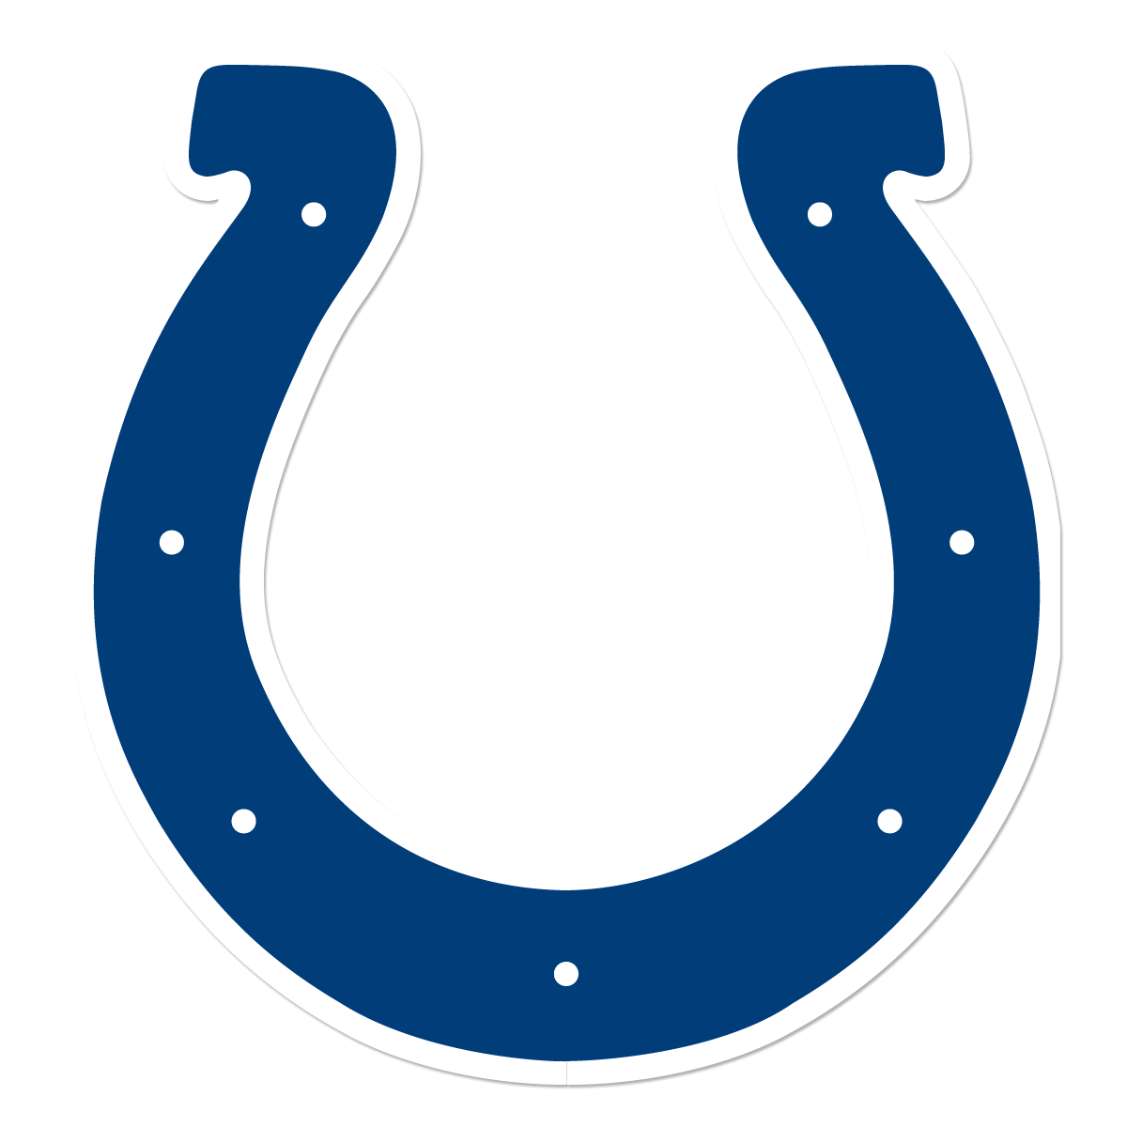**1.)** **Quarterbacks**

1. Pass Attempts
2. Passes Completed
3. Completion Percentage
4. Interceptions
5. Passing TDs
6. TD/INT Ratio
7. Passing Yards
8. Passer Efficiency Rating
9. Passer Rating
10. Completions Per Game
11. Yards Per Completion
12. Passing Yards Per Game

**2.)** **Offensive Skilled Players**

1. Rushing Attempts
2. Rushing Yards
3. Yards Per Rush
4. Rushing TDs
5. Rushing Yards Per Game
6. Fumbles Lost
7. Receptions
8. Receptions Per Game
9. Receiving Yards
10. Yards Per Reception
11. Receiving TDs
12. Receiving Yards
13. All Purpose Yards

**3.)** **Defensive Lineman**

1. Solo Sacks
2. Total Sacks
3. Sacks Per Game
4. Total Tackles
5. Total Tackles for Loss
6. Forced Fumbles

**4.)** **Predictors**

1. Quarterbacks
   * 1. 2020 Implications
2. Offensive Skilled players
   * 1. 2020 Implications
3. Defensive Lineman
   * 1. 2020 Implications
4. Defensive skilled
   * 1. 2020 Implications



**Summary**

The purpose of this project was to find which statistical categories should be looked at to aid in draft decision making. In this project, we found that there are entry level statistical categories that allow us to disregard many players and create a focal point on the players who deserve scouting. Additionally, the floors for the group of 5 should be considered higher than power 5 players’ floors.

1. **Quarterbacks**

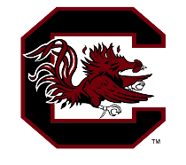Quarterbacks should be looked at by four categories with a lower floor required for group of 5 QB’s. The four categories are (i) Passing yards > 3500 (ii) >282 completions (iii) >25 pass TD’s (iv.) > 5.75 NFL Combine score. No current QB has all of these in the 2020 Draft class but look for Tua Tagolovia, K.J. Costello, Justin Herbert, Sam Ehlinger, Jake Bentley, Cole McDonald, Mason Fine, Jordan Love, and Brady White to be close in 2019-2020.



1. **Defensive Lineman**

Defensive lineman should be looked at by (i) total tackles for loss > 12 (ii) total tackles > 50 and (iii) at least 1 passed defended AND forced fumble. Players to watch include Kenny Willekes, Mike Danna, Bobby Roundtree, Carlos Basham Jr, Jonathan Garvin, Alex Highsmith, Yetur Gross-Matos, Patrick Johnson, and Bradlee Anae.





1. **Quarterbacks**
2. 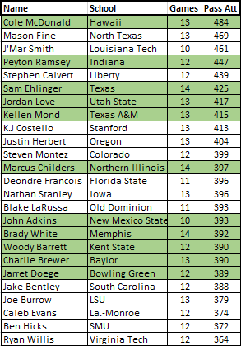[Pass Attempts](Macro%20practice.xlsx) (Out of Top 50 NCAA Leaders)[1]
3. 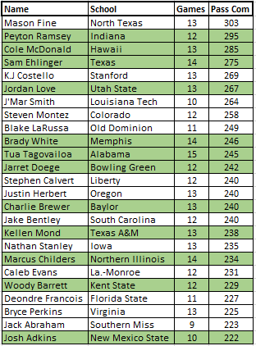Passes Completed (Out of Top 50 NCAA Leaders)[2]
4. 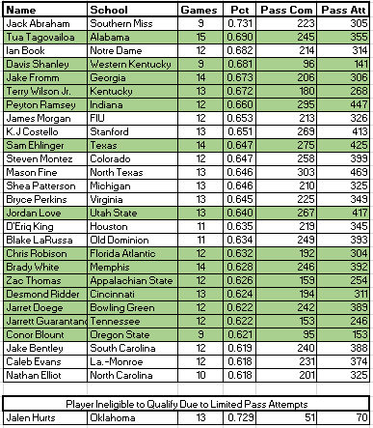Completion Percentage (Out of Top 50 NCAA Leaders)[3] [4]
5. Interceptions (Out of Top 50 NCAA Leaders)[5] [6]

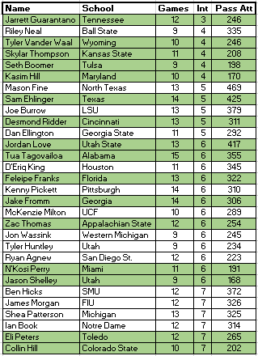

1. 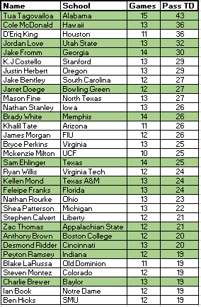Passing Touchdowns (Out of Top 50 NCAA Leaders)[7]
2. 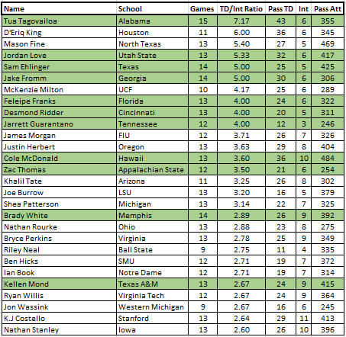TD to INT Ratio (Out of Top 50 NCAA Leaders)[8] [9]
3. Passing Yards (Out of Top 50 NCAA Leaders)[10]

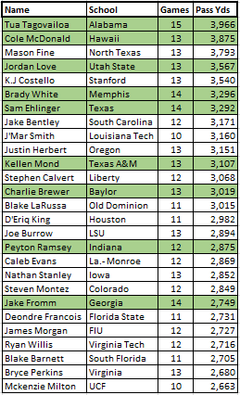

1. 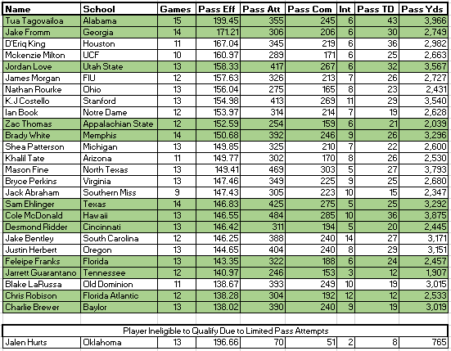Passer Efficiency Rating (Out of Top 50 NCAA Leaders)[11] [12]
2. 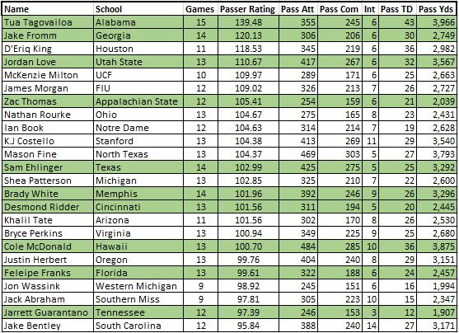Passer Rating (Out of Top 50 NCAA Leaders) [13] [14]
3. 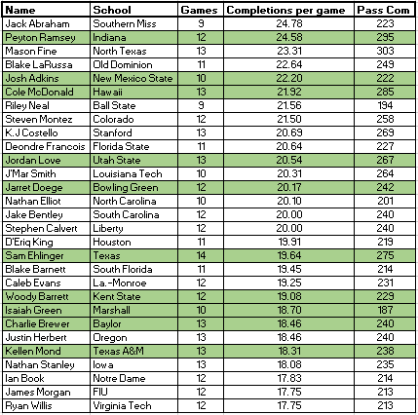Completions per Game (Out of Top 50 NCAA Leaders)[15] [16]
4. 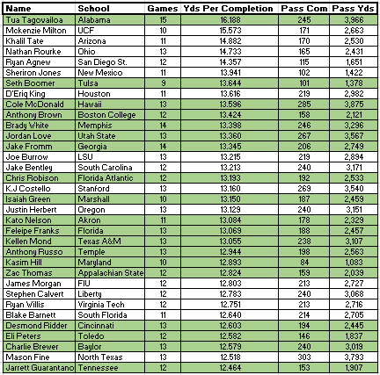Yards per Completion (Out of Top 50 NCAA Leaders)[17] [18]
5. 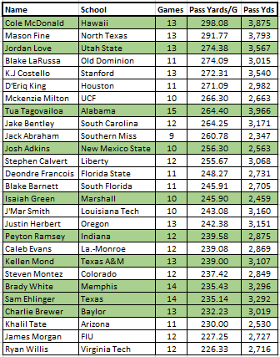Yards per Game (Out of Top 50 NCAA Leaders)[19] [20]

**2.)** **Offensive Skill Players**

i. Rush Attempts (Out of Top 50 NCAA Leaders)[21]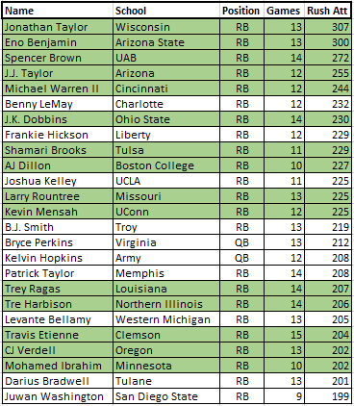

1. 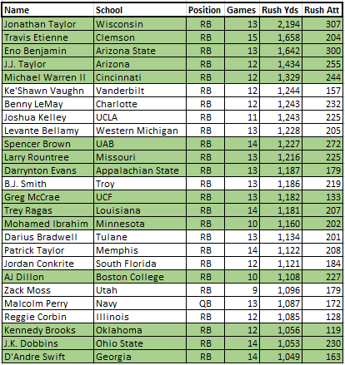Rush Yards (Out of Top 50 NCAA Leaders)[22]
2. 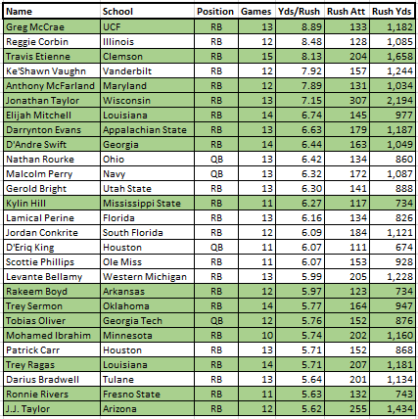Yards Per Rush (Out of Top 50 NCAA Leaders)[23] [24]
3. 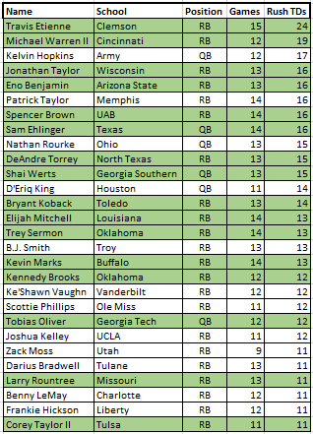Rushing TDs (Out of Top 50 NCAA Leaders)[25]
4. 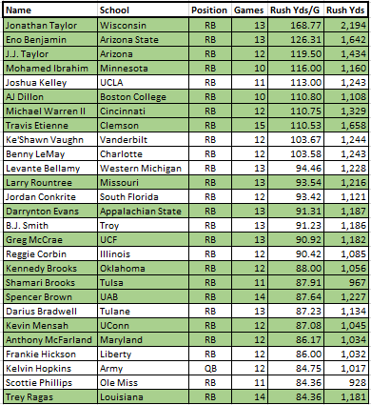Rushing Yds Per Game (Out of Top 50 NCAA Leaders)[26] [27]
5. 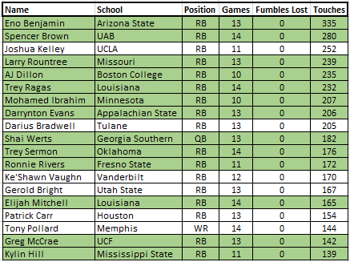Fumbles Lost (Top 19 in 2020 Draft Class)[28] [29]
6. 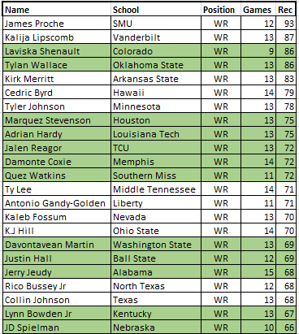Receptions (Out of Top 50 NCAA Leaders)[30]
7. 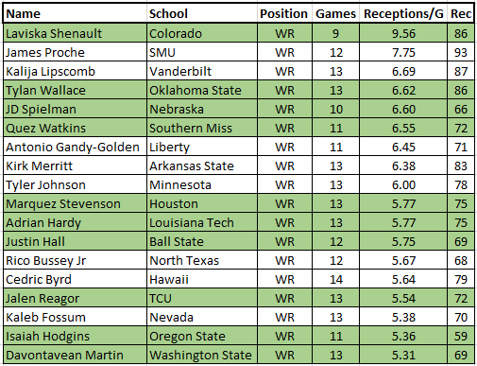Receptions per Game (Out of Top 50 NCAA Leaders)[31] [32]
8. 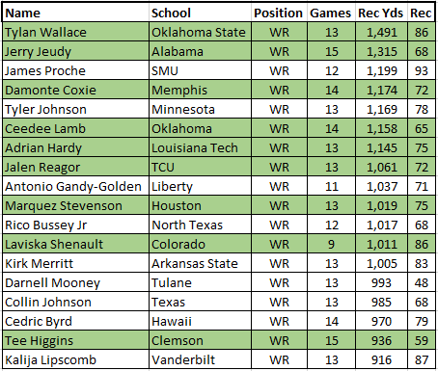Receiving Yards (Out of Top 50 NCAA Leaders)[33]
9. 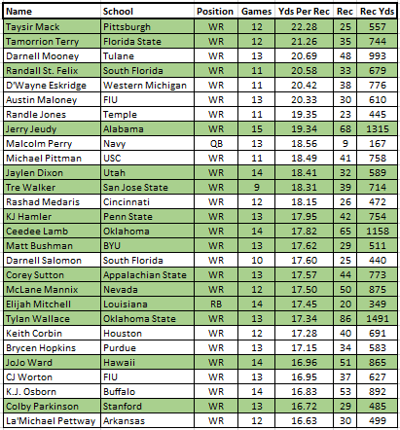Yards per Reception (Out of Top 50 NCAA Leaders)[34] [35]
10. 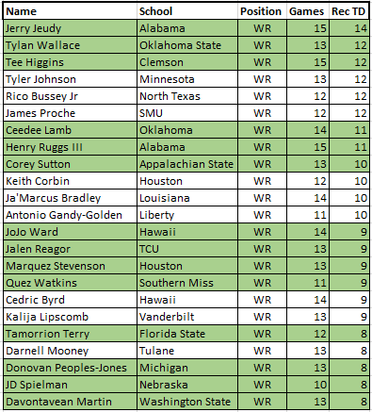Receiving TDs (Out of Top 50 NCAA Leaders)[36]
11. 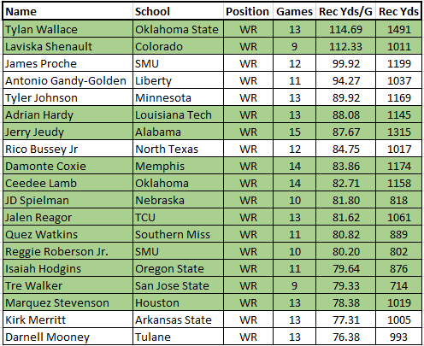Receiving Yards per Game (Out of Top 50 NCAA Leaders)[37] [38]
12. 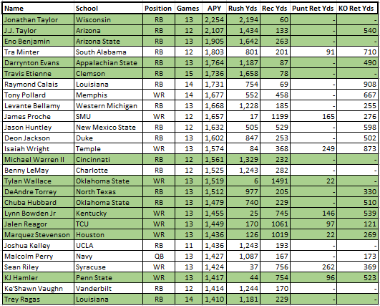All Purpose Yards (Out of Top 50 NCAA Leaders)[39] [40]

**3.) Defensive Lineman**

1. 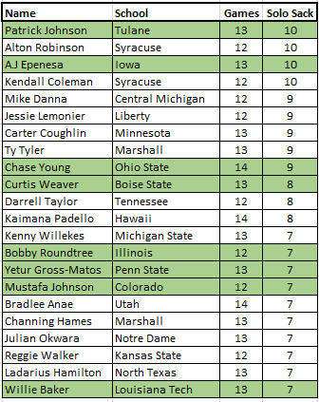Solo Sacks (Out of Top 50 NCAA Leaders)[41] [42]
2. 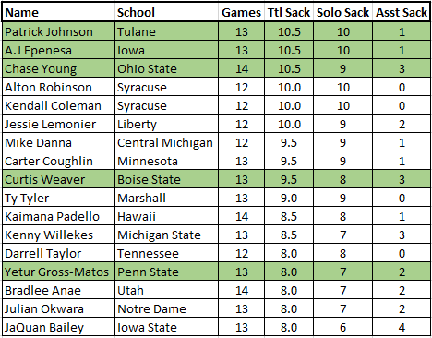Total Sacks(Out of Top 50 NCAA Leaders)[43] [44]
3. 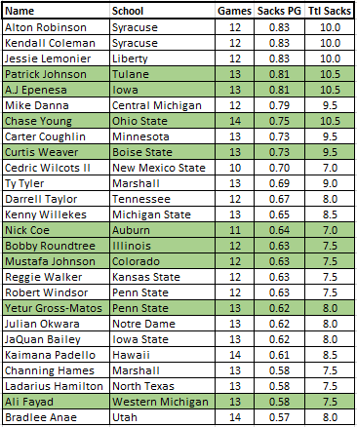Sacks Per Game(Out of Top 50 NCAA Leaders)[45] [46]
4. 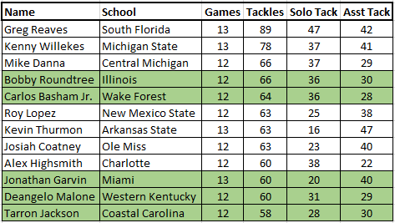Total Tackles(Out of Top 500 NCAA Leaders)[47] [48]
5. 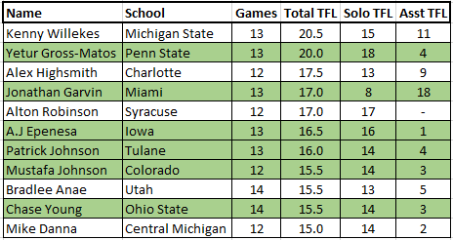Total Tackles for Loss(Out of 41 Eligible Players)47 [49]
6. 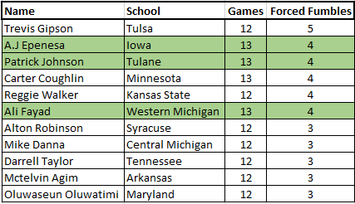Forced Fumbles (Out of 42 Eligible Players)[50] [51]

**4.)** **Most Predictive Stats by Position**

**A. Quarterbacks**

* + 1. **Passing Yards Greater than 3500 Yards**

Of the 84 NFL QB’s in the database, only 3 out of the 16 QB’s who have played in more than 75% of their possible games had less. 2 of these QB’s didn’t play a full NCAA season. 29 QB’s in total had less than 3500 yards indicating only ~10% of QB’s under that total. These 3 QB’s were at the bottom 12 of all QB’s in the database at 309 pass attempts or less.

**Reasoning:** Quarterback’s need to be able move the ball down the field. Passing yards indicate that they can do ss without relying on their running backs. Of the quarterbacks that had less than 3500, they were all on teams that typically run the ball heavy. Wisconsin is known for their power running scheme and the data implies that North Dakota State is a heavy running team since both QB’s drafted from NDSU are in the bottom 6 for pass attempts.

* + 1. **More than 282 completions in final NCAA Year**

Of the 84 NFL QB’s in the database, 11 out of the 16 QB’s who have played in more than 75% of their possible games had more than 250 completions. There are only 30 QB’s total that have more than 282 completions. While 10 of these QB’s failed to even play 25% of their potential games at the NFL level, 5 of them were in non-power 5 or FCS conferences. Thus, of the QB’s that were in Power 5 Conferences, 41% of those that threw more than 280 completions played in 75% of their potential games.

**Reasoning:** In order to move the ball down the field you have to complete passes. The only other option would be to run and the NFL typically hasn’t been to kind to running QB’s. Of the 2 Power 5 QB’s to not reach the 282-completion mark, one was a mobile QB in college (Lamar Jackson) and the other went to a heavy running team in Wisconsin (Russell Wilson).

* + 1. **Passing TD’s Greater than 25**

Of the 84 NFL QB’s in the database, only 2 out of the 16 QB’s who have played in more than 75% of their possible games had less. This is 9.5% of the 21 QB’s in total who have thrown below 25 TD’s and played a full season. Both of these QB’s didn’t play a full NCAA season and were in non-power 5 conferences. Furthermore, not a single power 5 QB threw below 25 TD’s and for those power 5 QB’s who have thrown 40 or more TDS, nobody has played under 50% of their potential games.

**Reasoning:** Quarterbacks that can’t score find their way to the bench. The only other option is a running TD which makes the QB overly reliant on the RBs and can hurt a dynamic approach. A quarterback that drives the ball 75 yards only to be stuck in the red zone provides limited benefits to a team. The QB’s who have thrown more than 25 TD’s in their final NCAA have shown they can score for their team.

* + 1. **NFL Draft Grade Greater than 5.75**

15/23 QB’s receiving a draft grade of 5.75 or better have played in more than 75% of their potential games. Only 3/23 of those QB’s played in less than 25% of their potential games.

**So which QB’s potentially in the 2020 NFL Draft should be looked at?**

Power 5 (Higher % of QB’s in the 25-75% of GP)

1. Tua Tagolovia: 3,966 yards, 245 completions and 43 TDs
2. K.J. Costello: 3,540 yards, 269 completions and 29 TDs
3. Justin Herbert: 3,151 yards, 240 completions and 29 TDs
4. Sam Ehlinger: 3,292 yards, 275 completions and 25 TDs
5. Jake Bentley: 3,171 yards, 240 completions and 27 TDs

Non-Power 5 (Higher % of QB’s with less than 25% of GP)

1. Cole McDonald: 3,875 yards, 285 completions and 36 TDs
2. Mason Fine: 3,793 yards, 469 completions and 27 TDs
3. Jordan Love: 3,567 yards, 267 completions and 32 TDs
4. Brady White: 3,296 yards, 246 completions and 26 TDs
5. **Offensive Skilled** 
   1. **\*Insert data here\***
6. **Defensive Lineman** 
   1. **Total Tackles for Loss Greater than 12**

In a sample of 135 NFL drafted defensive linemen, 46 of them had total tackles for loss greater than 12 and only 4 of them played in less than 25% of their potential games (8.6%).

**Reasoning:** Defensive lineman have to be able to rush the passer and stop the run. Tackles for loss indicate that the defensive lineman has the ability to get past the offensive line and make plays before they start.

* 1. **Total Tackles Greater than 50**

In the sample of 135 NFL defensive lineman, 45 had greater than or equal to 50 tackles in their final NCAA season. Only 3 of these players played less than 25% of their potential games (6.67%). Additionally, of the players who played a full season and had less 27 tackles (8), 75% of them have not played in more than one game.

**Reasoning:** Having the ability to tackle anywhere on the field shows a player’s playmaking ability. Defensive lineman that can not only get past the offensive line but also run and make tackles past the line of scrimmage are a great playmaking asset.

* 1. **At least 1 Pass Defended AND Forced Fumble**

In the sample of 135 NFL defensive lineman, 49 had defended at least one pass and forced one fumble. Only 6 of these players have played in less than 25% of their potential games (12%).

**Reasoning:** Defensive lineman need to have the ability to make plays and force turnovers to play. If a player has both of these stats it shows that they have the ability to make defensive plays at the line through pass breakups and cause turnovers from forcing fumbles.

**So which Defensive linemen potentially in the 2020 NFL Draft should be looked at?**

1. Kenny Willekes: 20.5 Total TFL, 78 Tackles, 1 Pass Def, 1 FF
2. Mike Danna: 15.0 Total TFL, 66 Tackles, 1 Pass Def, 3 FF
3. Bobby Roundtree: 12.5 TFL, 66 Tackles, 7 Pass Def, 1 FF
4. Carlos Basham Jr: 11.0 TFL, 64 Tackles, 1 Pass Def, 0 FF
5. Roy Lopez: 12.5 Total TFL, 63 Tackles, 1 Pass Def, 1 FF
6. Kevin Thurmon: 12.0 TFL, 63 Tackles, 0 Pass Def, 1 FF
7. Jonathan Garvin: 17.0 TFL, 60 Tackles, 5 Pass Def, 0 FF
8. Alex Highsmith: 17.5 TFL, 60 Tackles, 1 Pass Def, 2 FF
9. Tarron Jackson: 11.0 TFL, 58 Tackles, 0 Pass Def, 0 FF
10. Yetur Gross-Matos: 20.0 TFL, 54 Tackles, 0 Pass Def, 2 FF
11. Mustafa Johnson: 15.5 TFL, 51 Tackles, 0 Pass Def, 0 FF
12. Patrick Johnson: 16.0 TFL, 49 Tackles, 5 Pass Def, 4 FF
13. Carter Coughlin: 15.0 TFL, 48 Tackles, 0 Pass Def, 4 FF
14. Bradlee Anae: 15.5 TFL, 47 Tackles, 3 Pass Def, 2 FF
15. Rashad Weaver: 14.0 TFL, 47 Tackles, 4 Pass Def, 2 FF
16. JaQuan Bailey: 14.5 TFL, 46 Tackles, 4 Pass Def, 2 FF
17. Joe Gaziano: 12.5 TFL, 44 Tackles, 3 Pass Def, 3 FF

**Basic Assumptions Regarding Predictors**

1. The success criteria used for player analysis was games played. This was chosen as only good players will play, which is particularly true when looking at quarterbacks because there are only 32 of them that regularly play. The success criteria for defensive lineman should be retested using games started or certain in-game stats as games played allowed for a lot of success out of the drafted players. This most likely indicates that there’s a high turnover rate for defensive linemen, although, a look into undrafted defensive lineman and their success in games played could validate games played as a predictive measure.
2. Power 5 conference players are more coveted than non-power 5 conference players. Both defensive linemen and quarterbacks showed that the stats needed for non-power 5 conference players need to be much higher or are insignificant due to lower levels of competition. This can be seen through total tackles for loss being an insignificant indicator for non-power 5 conference defensive lineman and through many of the quarterback stats.
3. This list includes all potential early entries if they were inside each sample pool. This means that there may be players who later on decide to stay and will not declare for the 2020 NFL Draft.
4. The information collected came from the data collected below:
   1. [NCAA Stat Leaders 2020 Draft Class – 2018/2019 Data](NCAA%202020%20Draft%20Class%20data.xlsx)
   2. [Past NFL Draft Class Data – For Predictors](NFL%20data%20for%20NCAAF%20Comparing.xlsx) ; Please note:
      1. Red highlighted rows mean low success rate (<25%); typically, by games played as the measure
      2. Yellow highlighted rows mean medium success rate (25-75%); typically, by games played as the measure. Occasionally yellow highlight means inability to access data due to them not being enrolled at an FBS college
      3. Green highlighted rows mean high success rate (>=75%); typically, by games played as the measure
   3. [Excel file used to compile the data and put into tables](NCAA%20QB%20Screenshot%20Data.xlsx)

1. Green highlight indicates potential early entrant
2. Green highlight indicates potential early entrant
3. Green highlight indicates potential early entrant
4. Minimum of 15 passes per game; must play in 75% of team’s games
5. Green highlight indicates potential early entrant
6. Minimum of 14 pass attempts per team game
7. Green highlight indicates potential early entrant
8. Green highlight indicates potential early entrant
9. Minimum of 14 pass attempts per team game
10. Green highlight indicates potential early entrant
11. Green highlight indicates potential early entrant
12. Minimum of 15 attempts per game; must play in 75% of team’s games
13. Green highlight indicates potential early entrant
14. Minimum of 15 attempts per game; must play in 75% of team’s games
15. Green highlight indicates potential early entrant
16. Must play in 75% of team’s games
17. Green highlight indicates potential early entrant
18. Minimum of 15 passes per game; must play in 75% of team’s games
19. Green highlight indicates potential early entrant
20. Must play in 75% of team’s games
21. Green highlight indicates potential early entrant
22. Green highlight indicates potential early entrant
23. Green highlight indicates potential early entrant
24. Minimum 10 rushes per game; must play in 75% of team’s games
25. Green highlight indicates potential early entrant
26. Green highlight indicates potential early entrant
27. Must play in 75% of team’s games
28. Green highlight indicates potential early entrant
29. Minimum 100 touches
30. Green highlight indicates potential early entrant
31. Green highlight indicates potential early entrant
32. Must play in 75% of team’s games
33. Green highlight indicates potential early entrant
34. Green highlight indicates potential early entrant
35. Minimum 2 receptions per game; must play in 75% of team’s games
36. Green highlight indicates potential early entrant
37. Green highlight indicates potential early entrant
38. Must play in 75% of team’s games
39. Green highlight indicates potential early entrant
40. Must play in 75% of team’s games
41. Green highlight indicates potential early entrant
42. Must play in 75% of team’s games
43. Green highlight indicates potential early entrant
44. Must play in 75% of team’s games
45. Green highlight indicates potential early entrant
46. Must play in 75% of team’s games
47. Green highlight indicates potential early entrant
48. Must play in 75% of team’s games
49. Minimum 1.25 tackles for loss per game; must play in 75% of team’s games
50. Green highlight indicates potential early entrant
51. Minimum 0.25 forced fumbles per game; must play in 75% of team’s games